**Chapter 0**

**Synopsis**

**Title of the project**

Volunteer Management

**Statement about the problem**

Organizations and NGOs often struggle with efficiently managing volunteer engagement for their social welfare programs. Without a centralized platform, it's challenging for them to effectively communicate upcoming events and opportunities to potential volunteers. Similarly, volunteers face difficulties in discovering relevant events and coordinating their participation due to the lack of a centralized resource. This fragmented approach leads to missed opportunities, decreased volunteer engagement, and inefficient utilization of resources for social welfare initiatives.

**Why this topic?**

Creating a Volunteer Management System for social welfare programs addresses a critical need in our community. By providing a centralized platform for organizations, NGOs, and volunteers, we aim to bridge the gap between those in need of support and those willing to contribute their time and skills. This project aligns with the values of community engagement, social responsibility, and effective resource utilization, making it a compelling and impactful endeavor. Through this system, we can streamline volunteer engagement, enhance the effectiveness of social welfare programs, and ultimately contribute to positive social change.

**Objective and Scope**

**Scope:**

The scope of the system is to develop a robust volunteer management system that facilitates seamless communication and co-ordination between organisations , NGO’s and volunteers. The scope of the system is limited to Mumbai region, catering to organisations of various type including Non-Profit, Commercial, Educational, Government organisations, Healthcare, Charitable, Religious, Social organisations. This ensures that the system is tailored to specific needs and context of Mumbai community while being inclusive and accessible to a diverse range of organisations seeking volunteer support for their social welfare programs.

**Objectives:**

1. Provide a user-friendly interface for organisations and NGO’s to post events , manage Volunteer requirements , and track volunteer engagement.
2. Enable volunteers to easily discover , apply for, and participate in relevant social welfare events based on their interests, skills and availability.
3. Improve efficiency in volunteer management , event co-ordination and resource allocation for social welfare initiatives.
4. Foster a sense of community , collaboration and social impact among volunteers and organisations
5. Improving social interactions between volunteer by allowing them to participate and communicate with a diverse variety of people.

**Methodology**

For this System, Iterative development model would be more suitable because of the following reasons:

* Will allow continuous refinement and improvement based on feedback and evolving requirement.
* Offers flexibility in accommodating new features , addressing issues and incorporating user feedback at various stages.
* Encourages active involvement of stakeholders

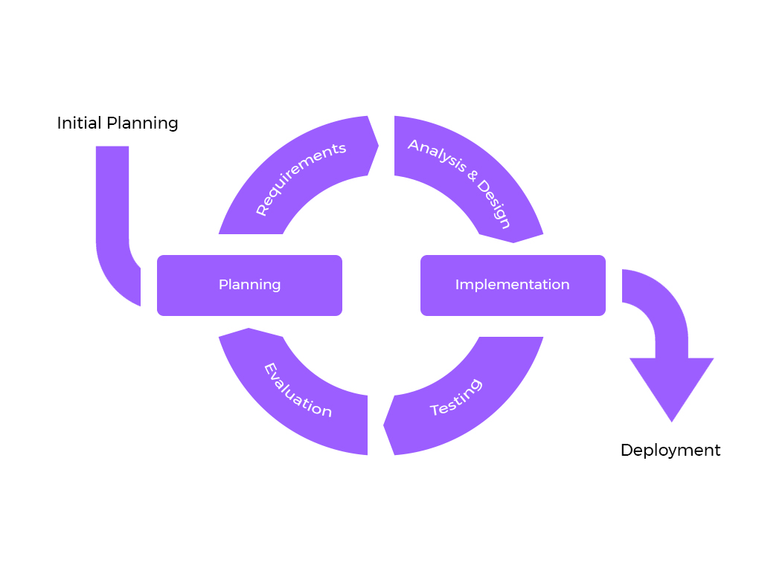

**Proposed Architecture**

The Project would be developed using a Client-Server 2 Tier Architecture, means organizing website in 2 main parts:

1. Client:

The User Interface and Presentation of the system will run on user’s device. Client is responsible for initiating request to server.

1. Server:

The Server component hosts the Application Processing and Data Storage, It responds to requests by processing the requests.

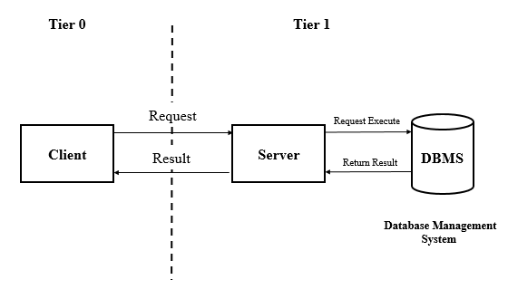

**Requirements**

1. Software Requirements:
2. Database: MySQL
3. Back-End: PHP
4. Front-End: HTML,CSS, Javascript (Jquery), Bootstrap, AJAX
5. Hardware Requirements:
6. A Basic computer with an decent processor such as intel i3 10th Gen or 11th Gen or AMD Ryzon 3 Processor
7. Ram: Minimum 4GB
8. HardDisk: 128GB or 256GB SSD, 4GB of available space
9. Monitor: 1200x800 Minimum screen resolution
10. Platform:
11. Visual Studio Code (VS Code)

**Contribution To Society:**

The Volunteer Management System contributes significantly to society in several ways:

1. Facilitating volunteer engagement and collaboration among organizations, NGOs, and volunteers.

2. Optimizing resource allocation for social welfare programs, enhancing their impact.

3. Improving communication, coordination, and feedback mechanisms for better program outcomes.

4. Fostering a culture of collaboration, knowledge sharing, and collective action within communities.

5. Empowering individuals to contribute meaningfully to social causes, promoting civic engagement and social responsibility.

**Conclusion:**

In conclusion, the development of a Volunteer Management System represents a significant step towards fostering a more connected, efficient, and impactful approach to social welfare initiatives. By bringing together volunteers, organizations, and NGOs on a centralized platform, the system streamlines volunteer engagement, optimizes resource utilization, and enhances the overall effectiveness of social welfare programs.

Through improved communication, collaboration, and empowerment of individuals, the system contributes to positive social change, stronger communities, and a more inclusive society.

**Chapter 1**

**Introduction**

* 1. **Background**

Traditionally, organizations have relied on methods such as word-of-mouth, flyers, local media advertisements, volunteer fairs, and referrals to recruit volunteers for their social welfare programs. While these methods are still relevant, they face several challenges in effectively managing volunteer engagement. These challenges include limited reach, resource-intensive processes, lack of centralization in information, communication barriers, and difficulties in tracking and reporting volunteer activities.

In response to these challenges, the proposed Volunteer Management System website aims to revolutionize volunteer hiring and management practices. By centralizing information about volunteer opportunities, providing efficient communication tools, automating processes such as volunteer matching and application management, implementing robust data tracking and reporting features, and expanding reach to a wider audience of potential volunteers, the website addresses the shortcomings of traditional methods. It streamlines processes, improves communication and coordination, enhances the volunteer experience, and ultimately contributes to more effective and impactful social welfare initiatives in the Mumbai region.

* 1. **Objectives**

Provide a centralized platform for organizations and NGOs to post volunteer opportunities for social welfare programs in the Mumbai region.

1. Provide a centralized platform for organizations and NGOs to post volunteer opportunities for social welfare programs in the Mumbai region.
2. Enable volunteers to easily find and apply for relevant volunteer positions based on their skills, interests, and availability.
3. Implement efficient communication tools to facilitate seamless interaction between organizations and volunteers, improving coordination and reducing communication barriers.
4. Expand the reach of volunteer opportunities to a wider audience, including non-profit, commercial, educational, and other organizations, fostering collaboration and collective impact for positive social change.
5. To reduce the time and efforts to search and recruit potential volunteer for a social welfare program by organizations.
   1. **Scope, Purpose and Applicability**
   2. **Purpose:**

The purpose of the Volunteer Management System website is to streamline volunteer engagement, enhance communication between organizations and volunteers, and Encourage community involvement and social responsibility by providing individuals and organizations with opportunities to contribute meaningfully to social causes and make a positive difference in their communities.

* 1. **Scope:**

The scope of the system is to develop a robust volunteer management system that facilitates seamless communication and co-ordination between organizations of various types such as non-profit, commercial, educational, government, religious organisations and volunteer’s for social welfare programs across Mumbai region.

* 1. **Applicability:**

The applicability of the Volunteer Management System website extends to various types of organizations and entities in the Mumbai region, including:

* + 1. **Non-Profit Organizations:** Non-profit organizations focused on social causes such as education, healthcare, environmental conservation, and community development can use the platform to recruit volunteers for their programs and initiatives.
    2. **Commercial Entities:** Commercial entities with corporate social responsibility (CSR) initiatives can leverage the platform to engage employees in volunteering activities, support local communities, and contribute to social welfare programs.
    3. **Educational Institutions:** Schools, colleges, and universities can utilize the platform to involve students, faculty, and staff in community service projects, awareness campaigns, and educational outreach programs.
    4. **Community Groups:** Local community groups, neighbourhood associations, and grassroots organizations can use the platform to organize volunteer-led activities, events, and campaigns for community improvement and social change.
    5. **NGOs and Charitable Foundations:** NGOs, charitable foundations, and advocacy groups working on various social issues such as poverty alleviation, human rights, and disaster relief can utilize the platform to recruit volunteers, coordinate relief efforts, and raise awareness.

The Volunteer Management System website is designed to be adaptable and accessible to a wide range of organizations and entities, offering a centralized platform for efficient volunteer management, collaboration, and collective impact in addressing societal challenges and promoting positive social outcomes in the Mumbai region.